Step to setup OOZIE:

1. Prerequisite:

* Install Mysql or use the instance which has Hive because hive install mysql while installation.
* Log in to mysql database:

**mysql -u root**

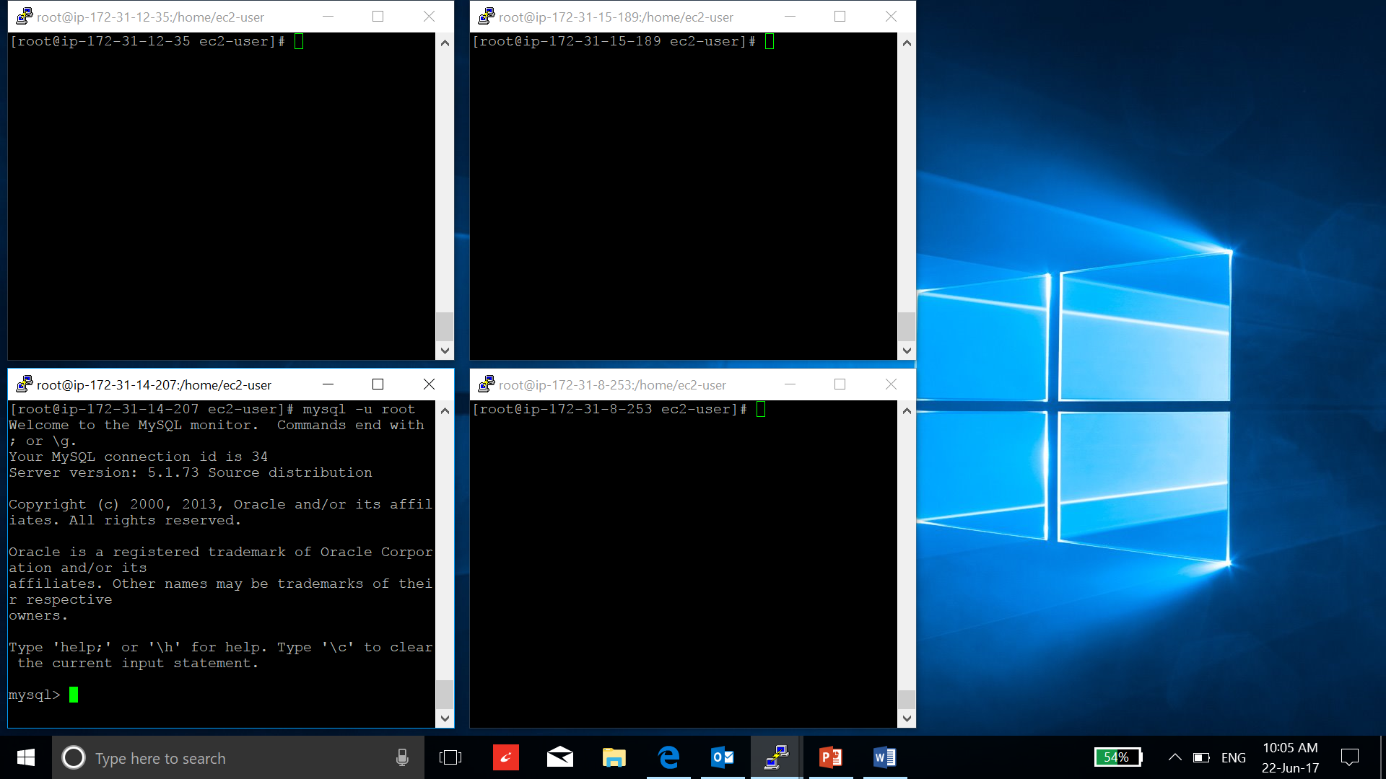

* Create database and user “OOZIE”:

**create database oozie;**

**create user 'oozie' identified by 'oozie';**

**grant all on oozie.* to oozie;**

**flush privileges;**

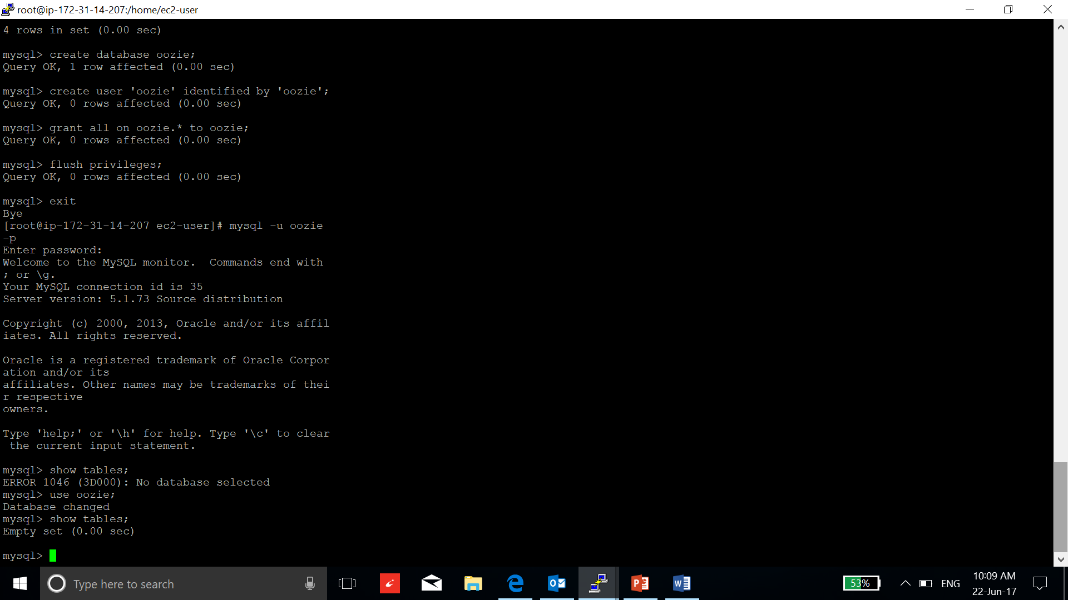

1. Go to ambari server and set the jar file for mysql:

**ambari-server setup --jdbc-db=mysql --jdbc-driver=/usr/share/java/mysql-connector-java.jar**

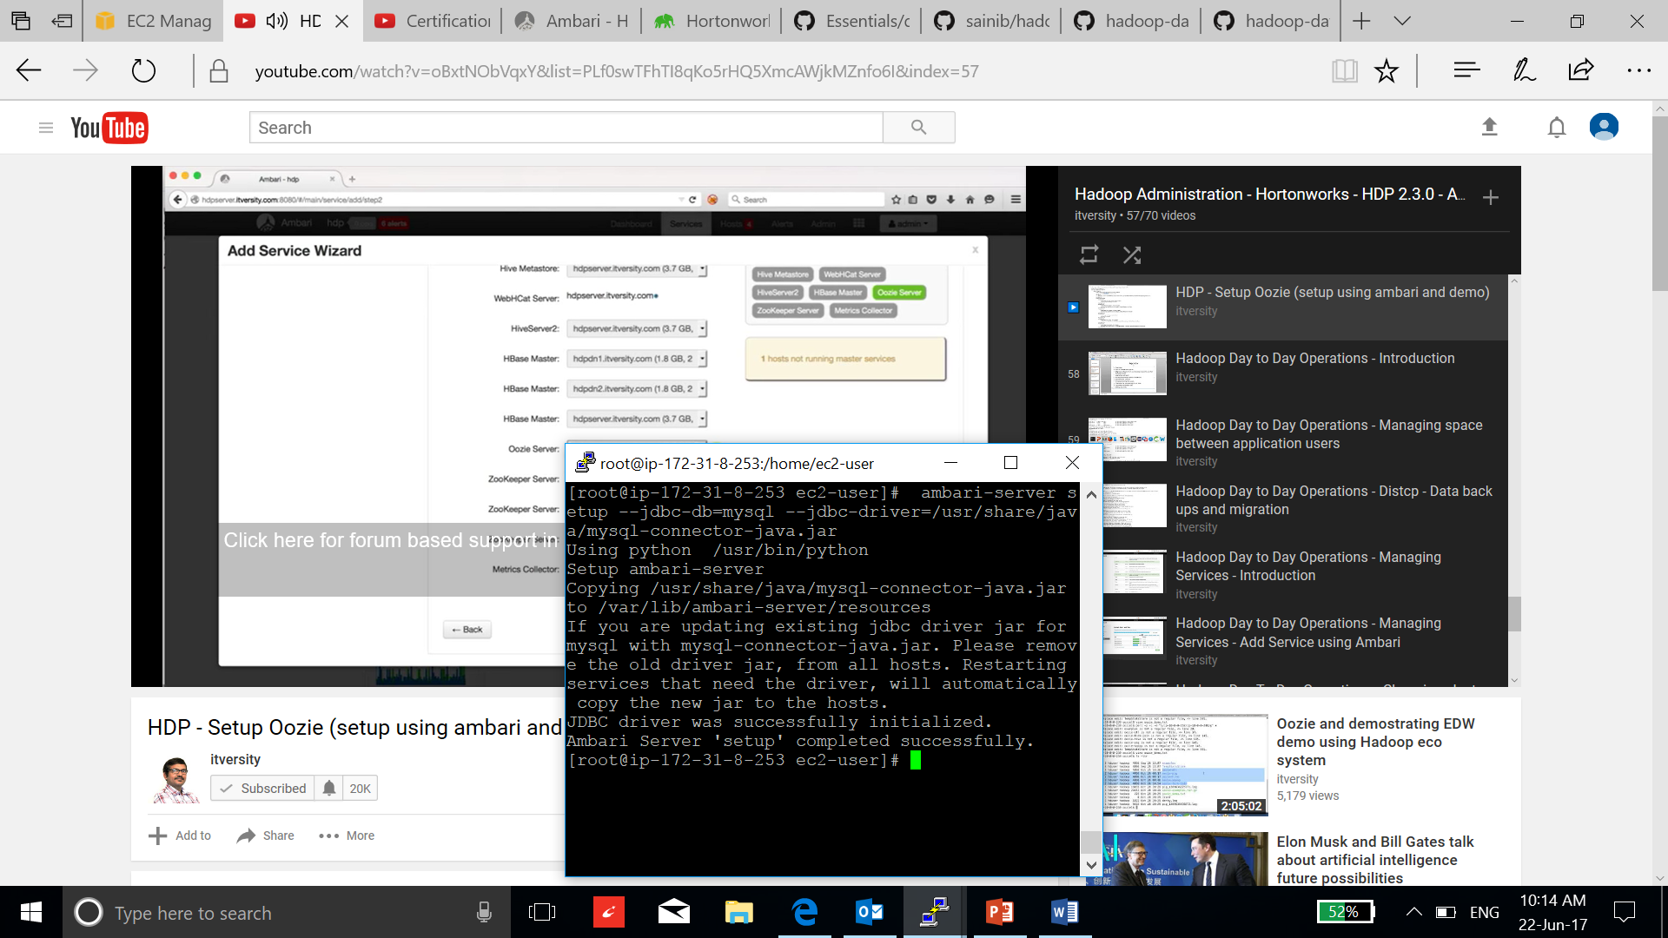

1. Now go to ambari interface and select Add Service:

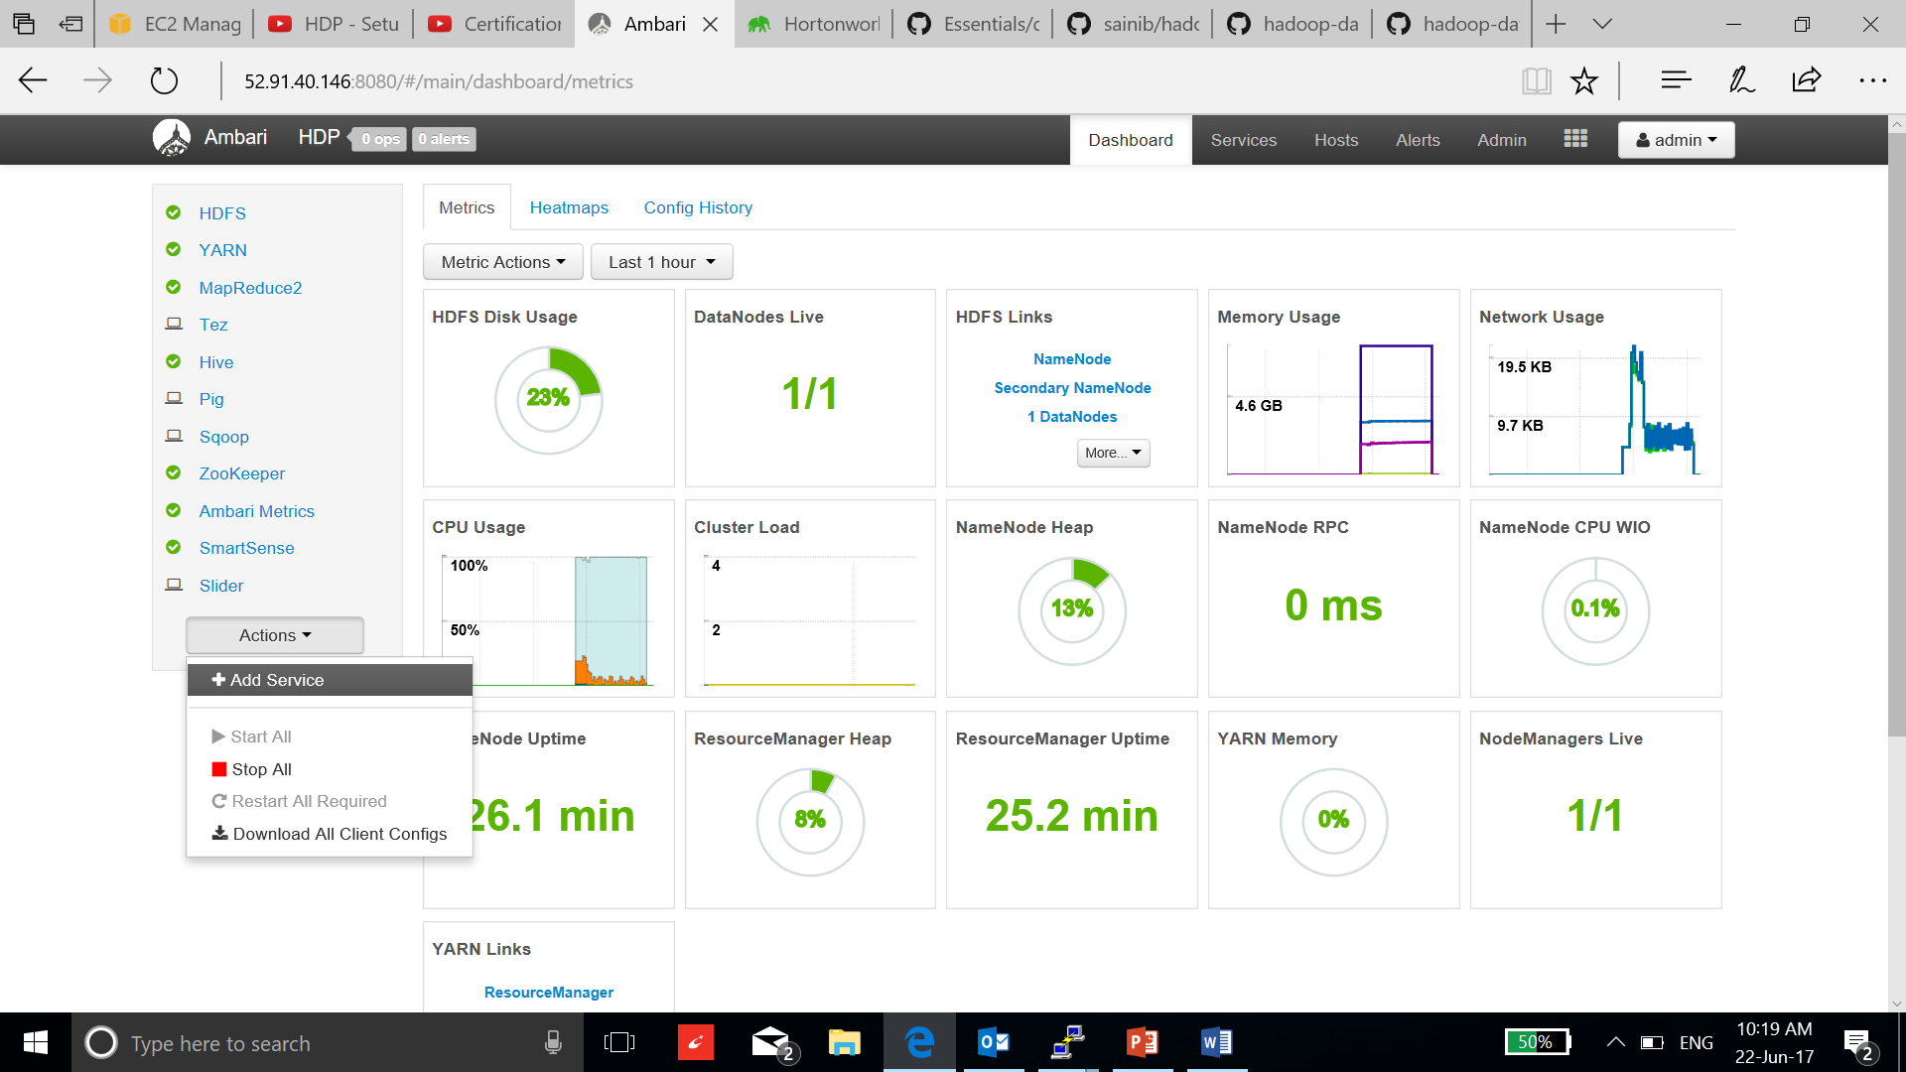

1. Select oozie and select next:

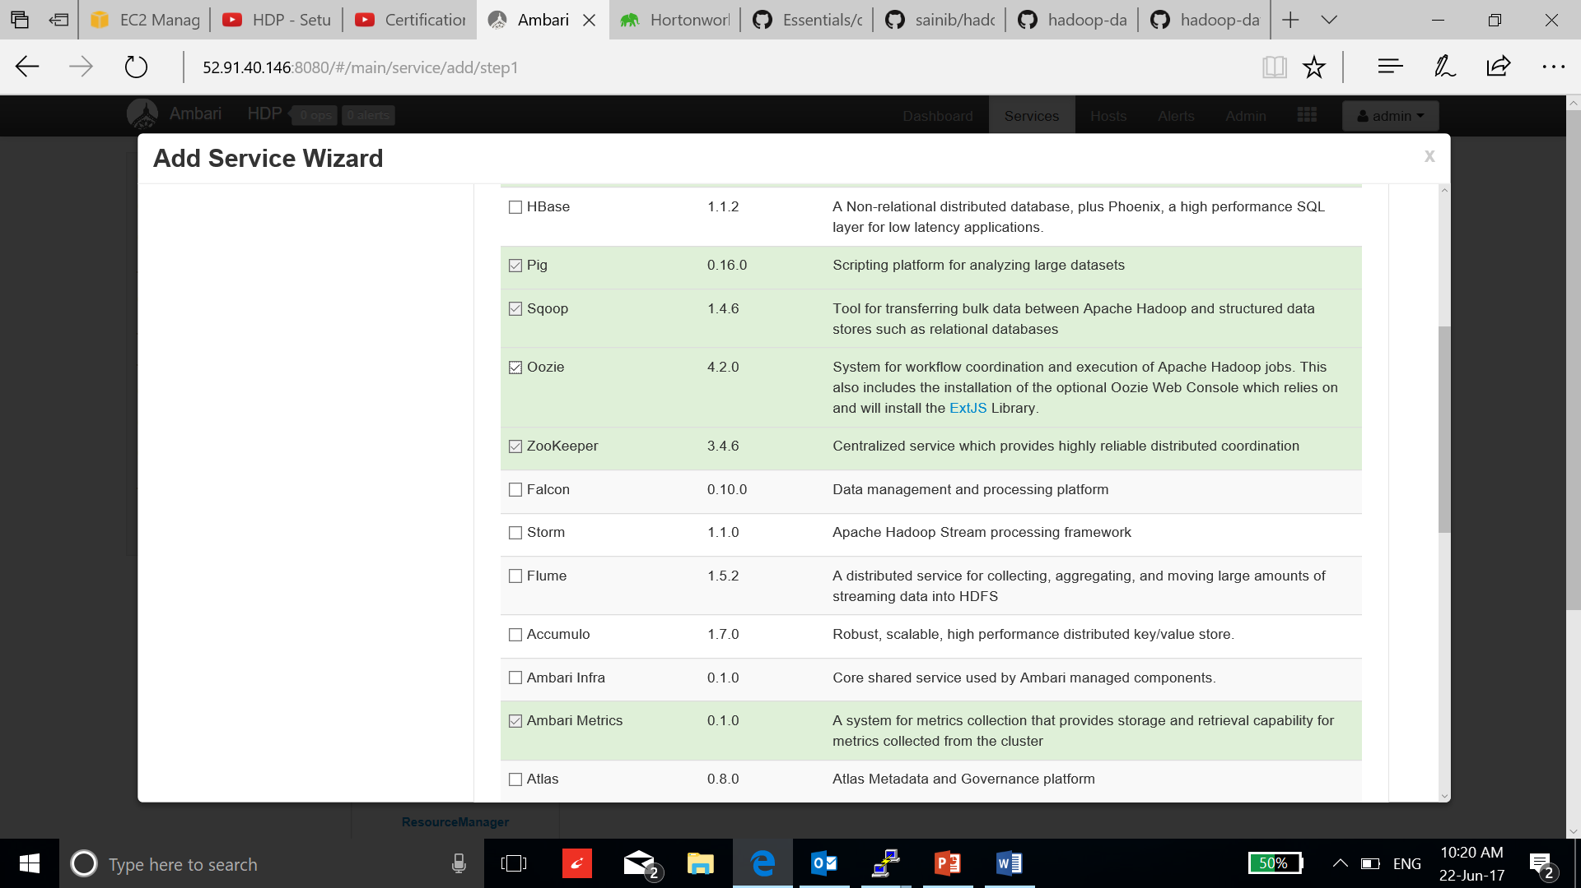

1. Choose the master cluster instance which has oozie database and Timeline server installed, click next:

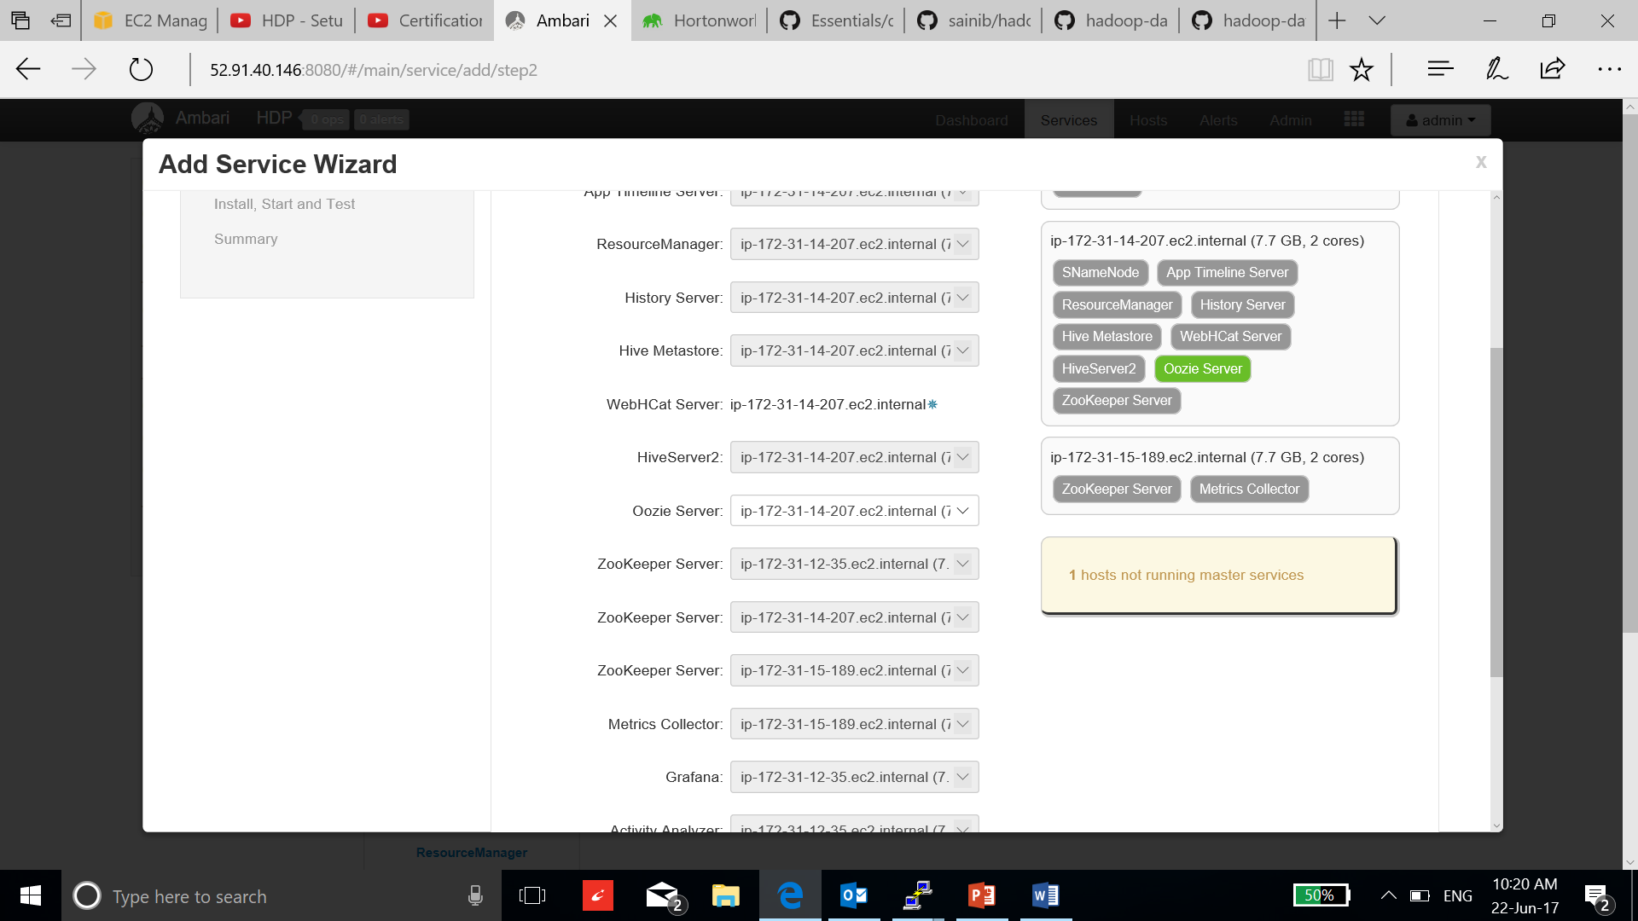

1. Select the client and go to next configuration page:

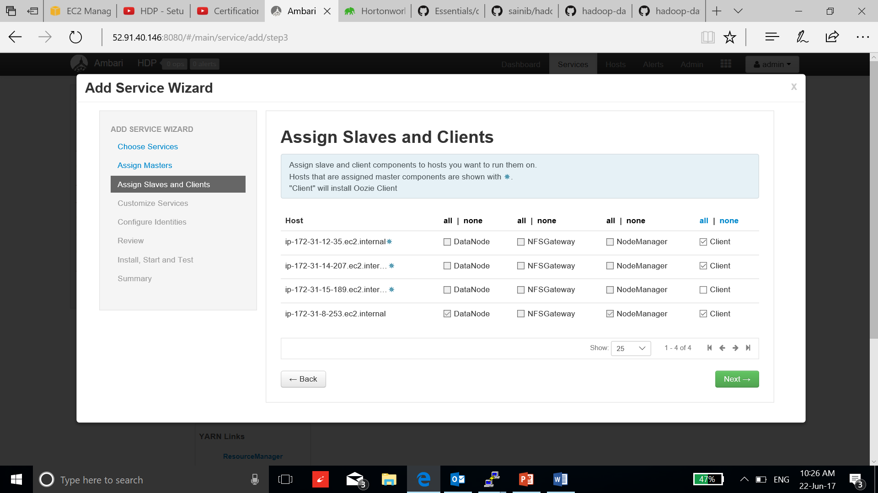

1. Now filled the details of created database and username, use the password and test connection:

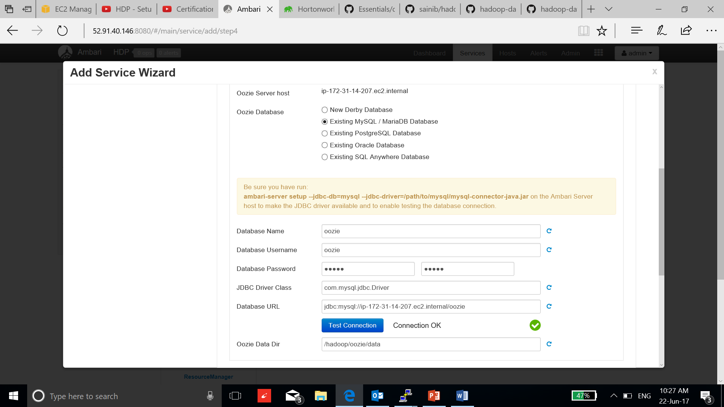

1. The recommended configuration window will pop up by ambari, click next to proceed:

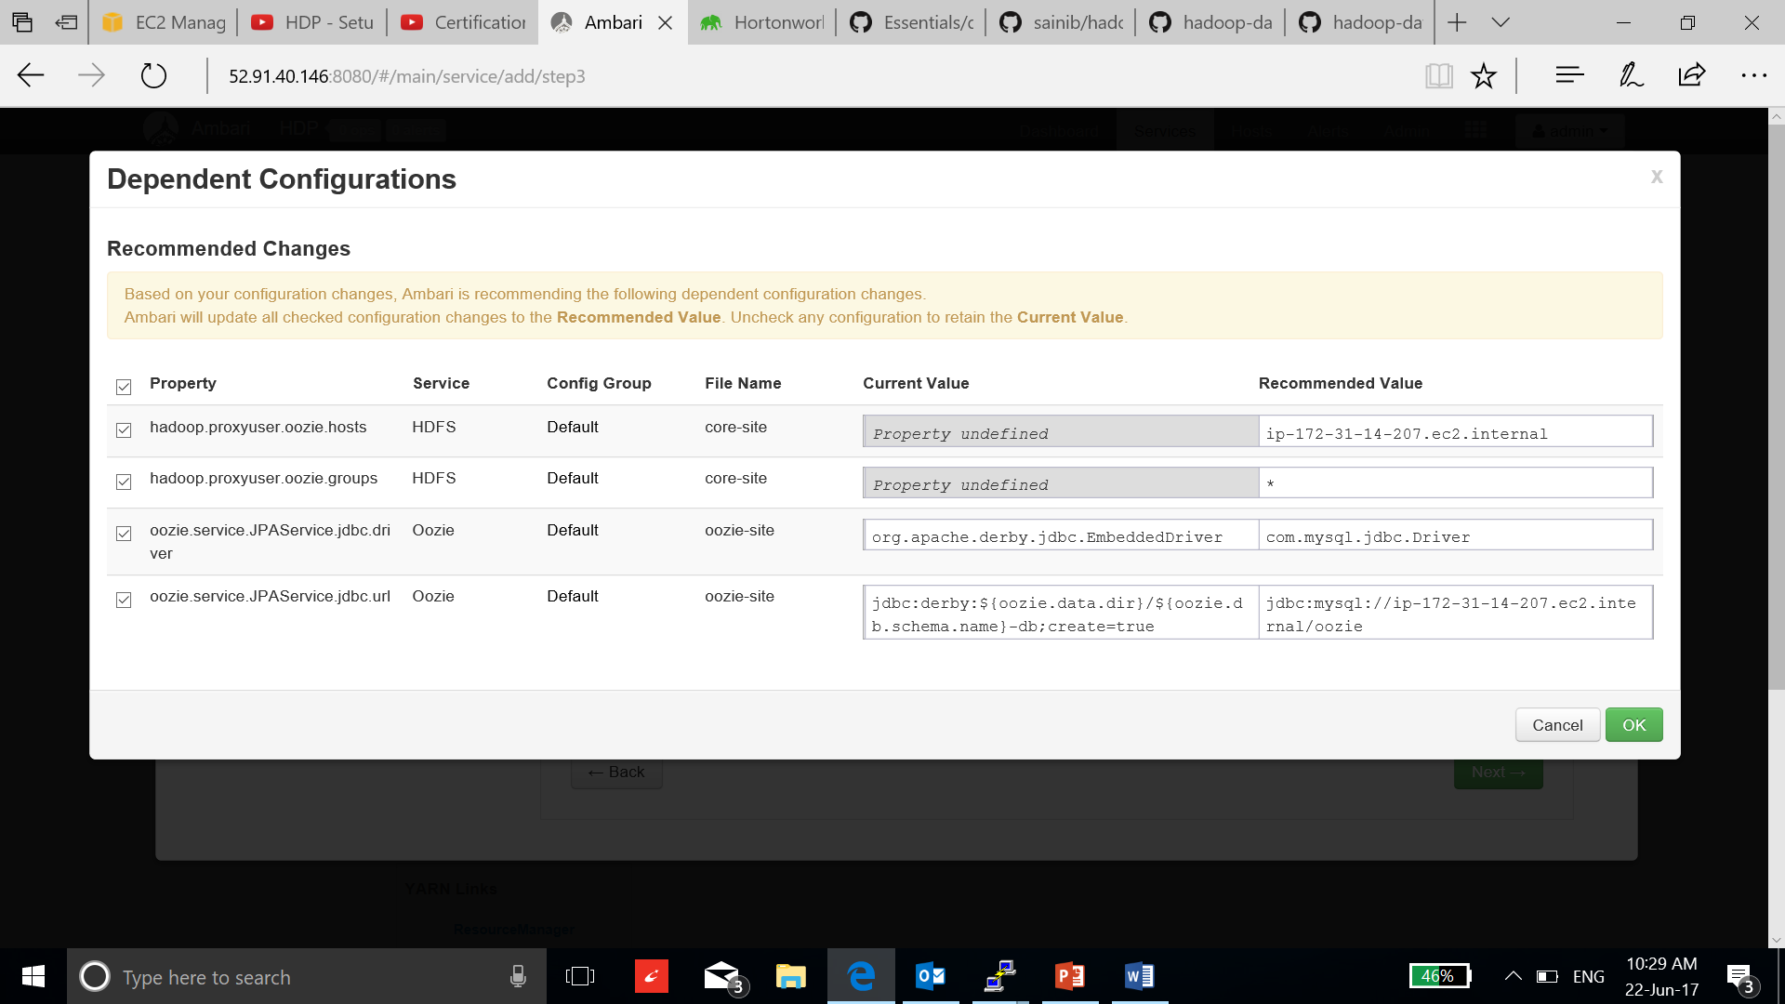

1. Review the configuration and select deploy:

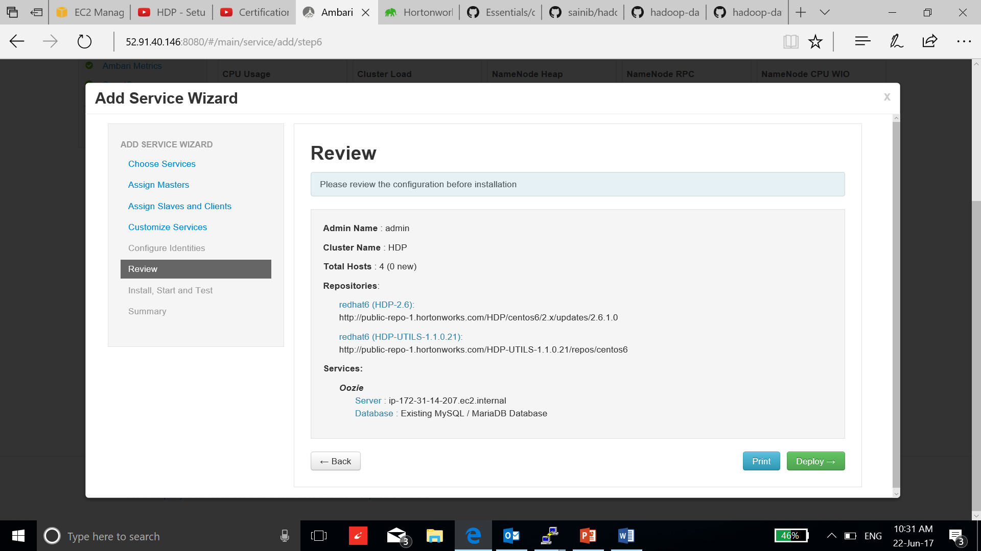

1. Once the installation is complete, select next and complete the process

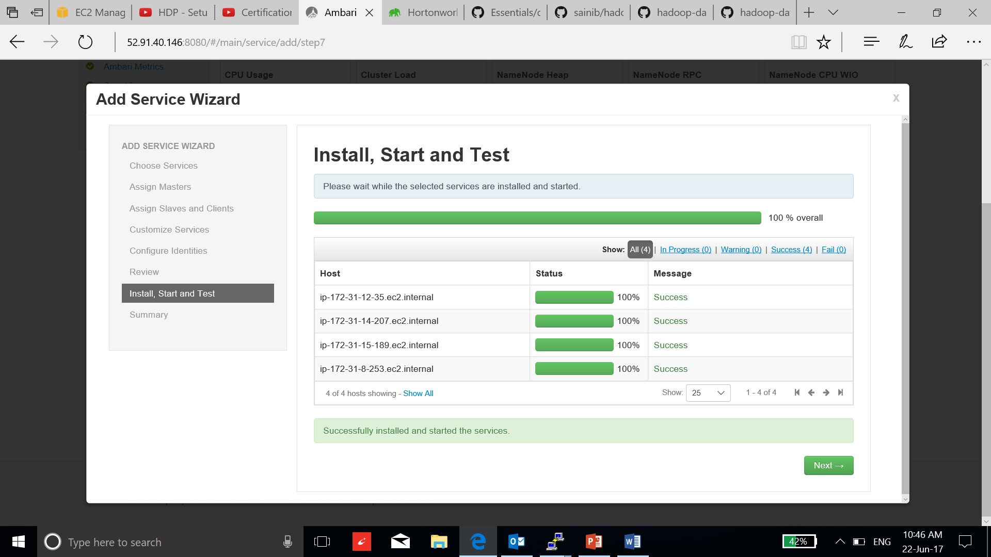

1. Now to check if the oozie server is running use the below command:

**oozie admin -oozie http://ip-172-31-14-207.ec2.internal:11000/oozie -status**

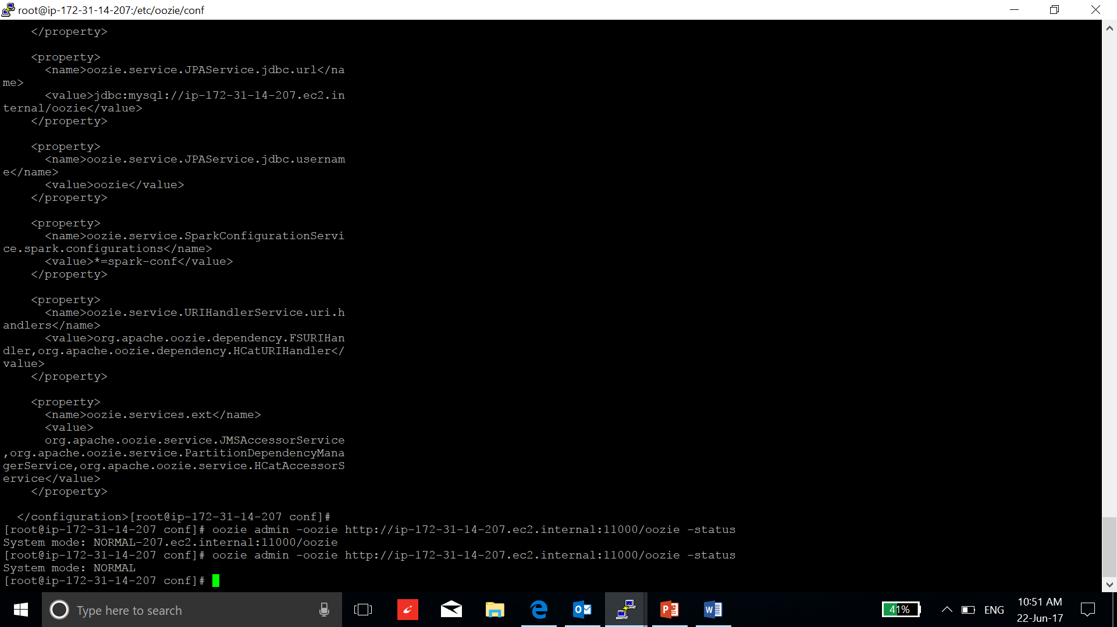

1. Follow the steps to run the oozie examples:

**find / -name "*oozie*examples*.tar.gz"**

**cp /usr/hdp/2.6.1.0-129/oozie/doc/oozie-examples.tar.gz .**

**tar xzf oozie-examples.tar.gz**

**vi /root/examples/apps/map-reduce/job.properties**

Change the namenode address and job tracker address:

Find the address:

**vi /etc/hadoop/conf/yarn-site.xml**

**vi /etc/Hadoop/conf/hdfs-site.xml**

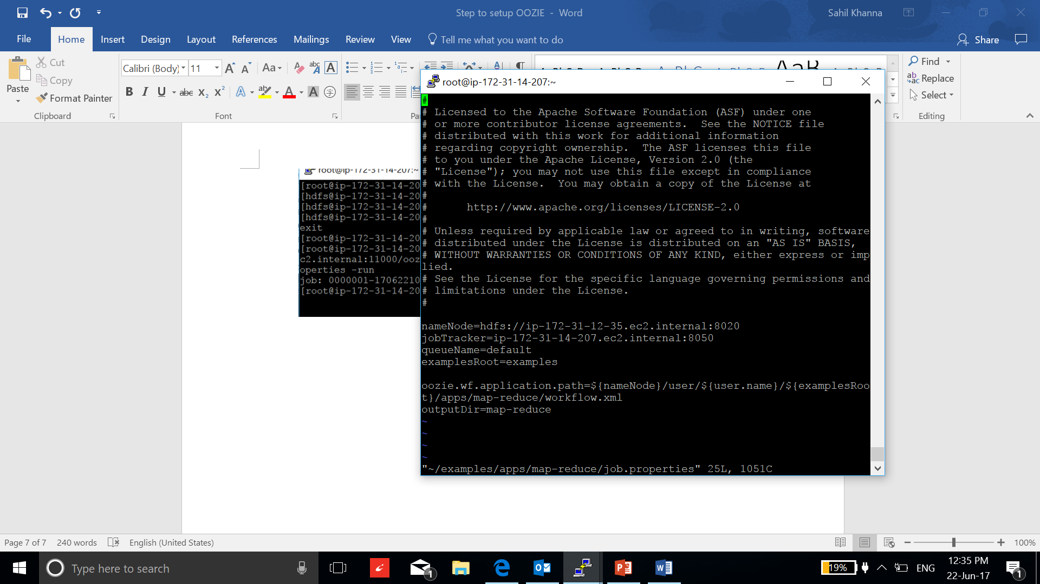

Now go to the home directory and transfer the “examples” directory to the /user/root in hdfs and run oozie start command:

**oozie job -oozie http://ip-172-31-14-207.ec2.internal:11000/oozie -config /root/examples/apps/map-reduce/job.properties -run**

